The Clubhouse
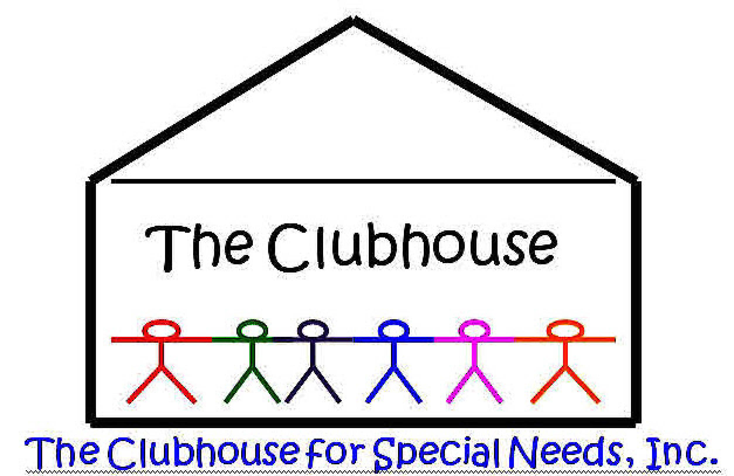

For Special Needs, Inc.

For the mild to moderate mentally/ physically challenged teenagers and young adults.

Volunteer Application

NAME: ___________________________________________________________________

ADDRESS: _________________________________________________________________

CITY: STATE: ZIP: ________ PHONE:_________________

Driver’s License or Texas ID Number: ___________________________________________

Email: ___________________________________________________________________________________

Position: VOLUNTEER ____________________________________________________
Full-Time N/A Part-Time N/A Total Hours ______
_____ Driver’s license /Texas ID Need a copy
_____ Background Check
_____ References [use back of page – at least three]
NAME OF PERSONS TO CALL IN CASE OF AN EMERGENCY:
Name ____________________________________ Relationship _________________ Phone _____________________________

Name ____________________________________ Relationship _________________ Phone _____________________________

Name ____________________________________ Relationship _________________ Phone _____________________________

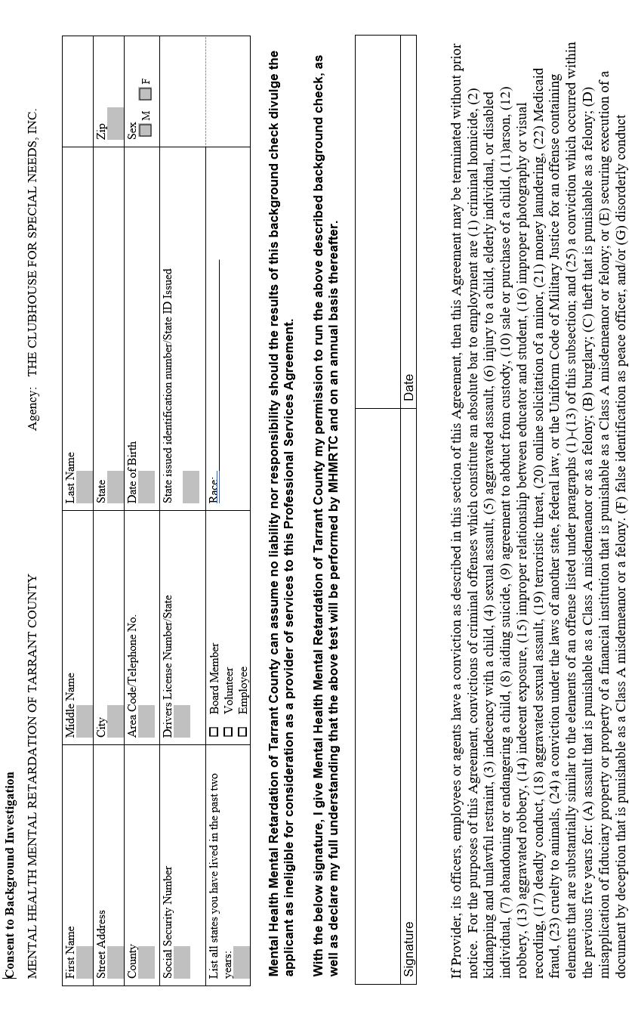
VOLUNTEER GUIDELINES
The Clubhouse for Special Needs is very pleased that you have decided to volunteer here. Below is a little information to make your time with us a wonderful experience.
MISSION STATEMENT: to provide a safe and fun place for teens and young adults with mild to moderate, mental/physical challenges – an opportunity for education, socialization and independence in a recreational atmosphere.

- Interact with our young people by conversation, playing games, computers, Wii, etc.
- Assist where assistance is needed. Encourage them to do it themselves.
- Have the young person return any items used, i.e. arts/crafts, games.
- Have a positive attitude and conversation with everyone.
- The lounge is a good place to just hangout – rule is no guys and girls on the same sofa.
- Bathrooms – Only one person in a bathroom at a time. Staff and volunteers are never to be behind a closed door with our kids.
- Do not offer food, candy, gum, medications, etc. to our young people.
- We discourage cell phone usage, i.e. calls, texting.
- Dress/Attire: Modest attire, free from inappropriate words/symbols, low cut tops and short shorts.

I, _________________________________, have read, understand, and agree to the Volunteer Guidelines. I further understand and agree that these guidelines may be revised at anytime .
_______________________________________ ____________
Signature Date

